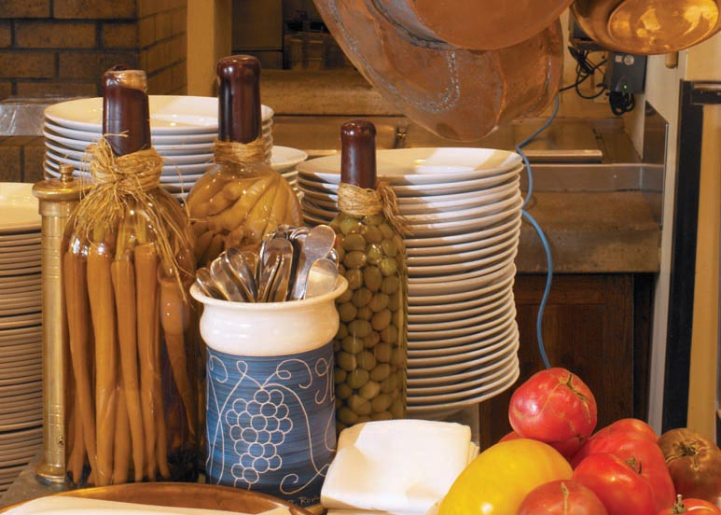

Open Mon-Wed 10am-9pm, Thur-Sun 11am-10pm

www.facebook.com/SweetTemptationsForYou

## Sweet Temptations



### Breads $3.75-6.95 per slice/$8.95-10.45 whole

### Quick Breads $3.00 Per slice

### Swedish Rye

### Country Loaf

### Sticky Buns

### Cinnamon Rolls

### *Pumpkin-Nut*

### Apple Coffee Cake

### Orange-Cranberry Nut

### *Pumpkin Spice*

### Banana-Chocolate Chip

### Banana Bread

### *Blueberry Crumb*

### Mocha-Nut Bread

### Buttermilk Biscuts

### *Apple Streusel Bread*

### Rosemary Focaccia

### *Buttermilk*

### Poppyseed

### Raisin & Walnut Rustic

### *Cinnamon Swirl With/Without Raisins*

### Challah With/Without Raisins

### *Marble Rye*

### *Sourdough*

*Honey Wheat*

French Bread

### *Parmesaean Focaccia*

## Sweet Temptations

### *Blueberry with Streusel*

### *Cranberry-Walnut*

### Mango

### *Raspberry-Almond*

### *Bran*

### Multigrain

### *Apple-Cinnamon*

### *Strawberry*

### Honeysuckle

### *Tiramisu*

### *Lemon*

### S’mores

### *Banana-Fudge*

### *Chai Latte*

### Chocolate chip

### *Red Velvet*

### *Dark Chocolate*

### Cupcakes $3.00/$36.00 per dozen

### Key Lime

### Lemon Blueberry

### *Poppyseed*

### *Mint-Chip*

### Orange Cranberry

### *Banana*

### *Mixed Berry*

### Blackberry

### *Chocolate Chip*

### *Lemon-Poppyseed*

### Mocha-Chip

### *Strawberry-Banana*

### *Blueberry*

### Muffins $2.75/ $33.00 per dozen